MGMT 30500: Assignment 6 – Fall 2024

Due Date: October 29, 11:59 pm

Part B | Points
1 | 6
2 | 6
3 | 6
4 | 5
5 | 5
6 | 5
7 | 6
8 | 5
9 | 6
Total | 50

PART A. (No problems from the text.)

PART B. Nine questions.

For each question, briefly explain why you chose your answer. Without explanations, there will be no points.

A marketing consultant for a cereal company is investigating the effectiveness of a TV advertisement for a breakfast cereal. The consultant shows the advertisement in a specific community for one month. Then, she randomly samples 100 shoppers as they leave a local supermarket to ask whether they viewed the Ad (Yes or No), whether they had at least a college degree (Yes or No), and whether they purchased the new cereal (1 if purchased, 0 otherwise). The consultant also asks the subjects about their annual household Income ($1000) and number of children. Data is recorded in Minitab (partially shown below) and a binary logistic regression is fit. The output is below (pages 2-3).

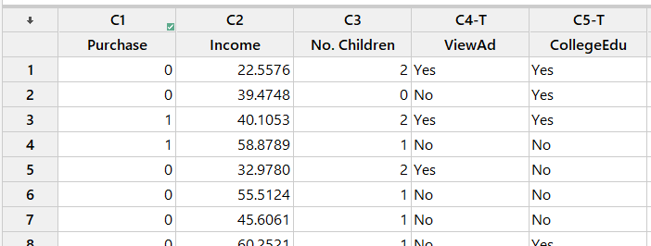

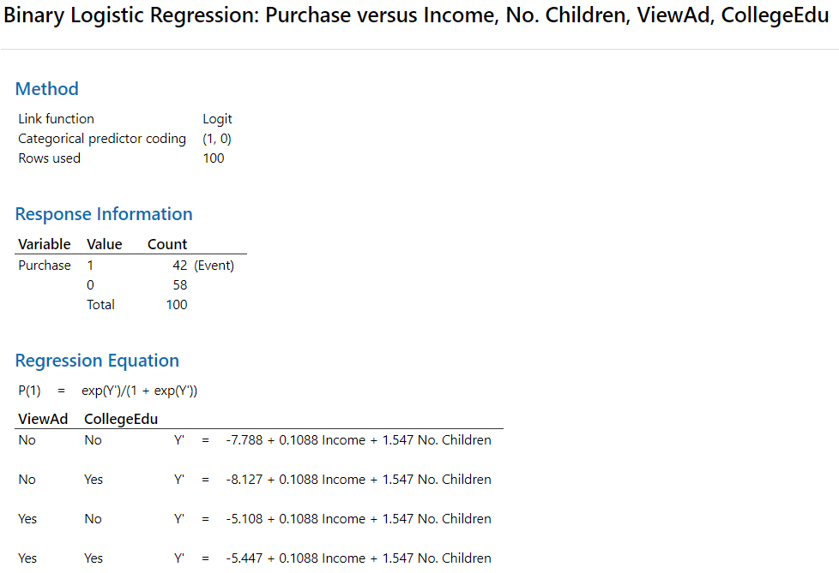

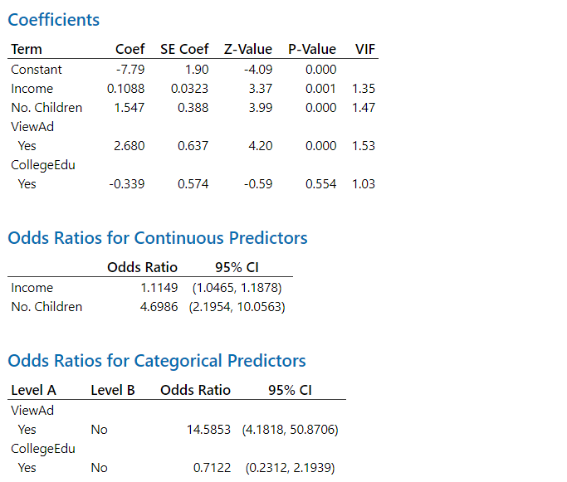

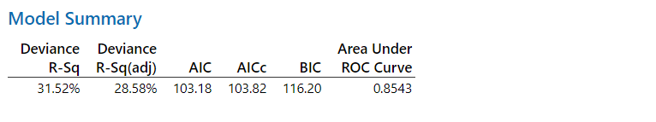

- Which of the following model-free prediction methods (i.e., without using the predictor variable) provides a better result for a new but similar data set?
- All 100 shoppers purchased the new cereal.
- All 100 shoppers did not purchase the new cereal

- Define the event of interest in this case. Also, describe the odds of the event.

- Write down the prediction equations for predicting the probability of the event.

- Based on this model, for a shopper who has an income of $55,000, no children and a college degree, and who saw the ad, the predicted probability that he/she will buy the cereal is:
- 0.631
- 0.537
- 0.989
- 0.716
- 0.335

- Controlling for Income, No. Children and CollegeEdu, which of the following is correct?
- For a person who viewed the ad, the predicted probability they will buy the cereal increases by a factor of 2.682.
- For a person who viewed the ad, the predicted odds they will buy the cereal increase by a factor of 2.682.
- For a person who viewed the ad, the predicted odds they will buy the cereal increase by a factor of exp(2.682) ≈ 14.5853.
- For a person who viewed the ad, the predicted probability they will buy the cereal increases by a factor of exp(2.682) ≈ 14.5853.

- At the 5% level, which of the predictors in this model individually has/have a significant effect on the probability of purchasing the cereal?
- All predictors.
- Only No. Children and ViewAd.
- No predictor is significant.
- All predictors except CollegeEdu.
- Cannot be determined based on the output.

- If the odds of an event are 8 to 1 for the event, what is the probability of the event?
- 0.900
- 0.909
- 0.889
- 0.125

- Controlling for ViewAd, No. Children, and CollegeEdu, which of the following is correct?
- The probability of purchasing the cereal is predicted to increase by 0.1088 per unit increase in Income.
- The odds of purchasing the cereal is predicted to increase by 0.1088 per unit increase in Income.
- The odds of purchasing the cereal is predicted to decrease by a factor of exp(0.1088) per unit increase in Income.
- The probability of purchasing the cereal is predicted to increase by a factor of exp(0.1088) per unit increase in Income.
- The natural log of the odds of purchasing the cereal is predicted to increase by 0.1088 per unit increase in Income.

- Between the random prediction (in Problem 1) and prediction with logistic regression, which is expected to perform better in terms of the prediction accuracy? Why?

